16.3 Editors - Timeline - Sidebar
Dopesheet Editor - Sidebar 1
Sidebar - View Tab - Marker options panel 1
Lock Markers 1
Sidebar - View Tab - View options panel 1
Show Markers 1
Only keyframes from selected channels 1
Only show errors 1
Show Seconds 2
Sync visible range 2
Sidebar - Cache Tab - Cache panel 2
Show Cache 2
Softbody, Particles, etc. 2

Dopesheet Editor - Sidebar
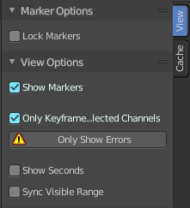
The sidebar contains further options.

It is closed by default. You have to reveal it first.

Sidebar - View Tab - Marker options panel

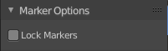
Lock Markers
Make the markers uneditable.

Sidebar - View Tab - View options panel
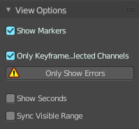

Show Markers
Display the markers row at the bottom of the view.

Only keyframes from selected channels
Just show the keyframes from the seleced object.

Only show errors
Only include f-curves that are disabled or have errors.

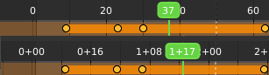
Show Seconds
Show the timing in the timeline area in seconds instead of frames.

Sync visible range
Synchronize the visible timeline range with other visible time based editors.

Sidebar - Cache Tab - Cache panel

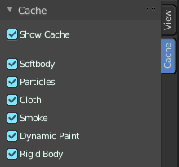
Show Cache
Show animation information for chached objects like Particles.

Softbody, Particles, etc.
Include or exclude what kind of chache types you want to display.

